**Big Data Management - Assignment 3**

**AmazonRDS**

**Akshay Kumar (G24AI1033)**

**Task 1 : Inserting the data**

**Code :**

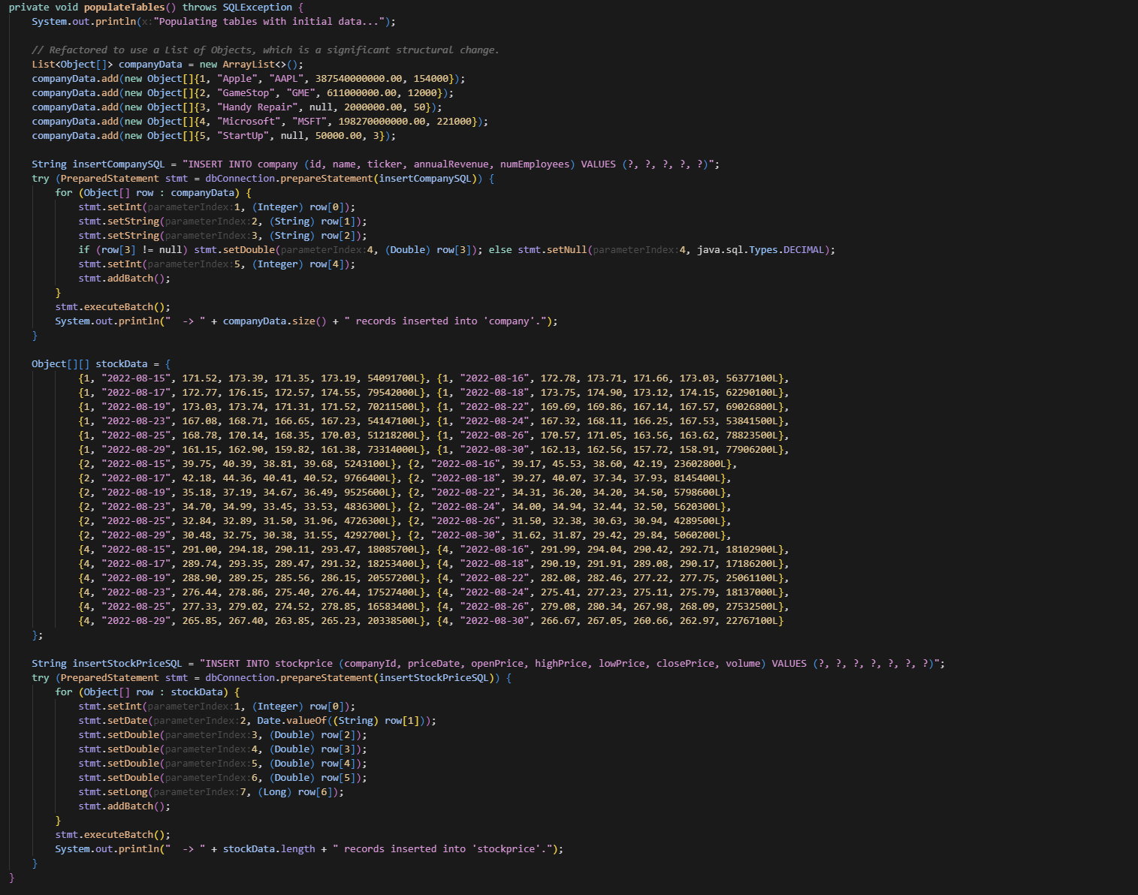

**Screenshot of the data :**

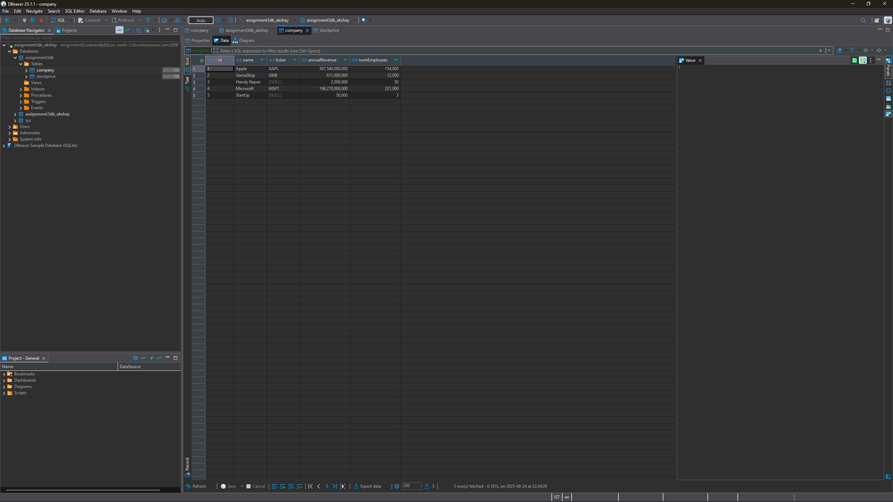

**Task 2 : Deleting the data**

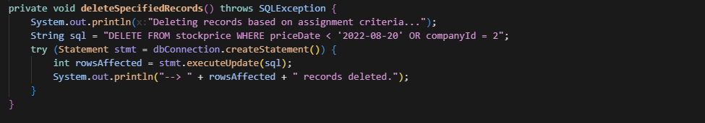

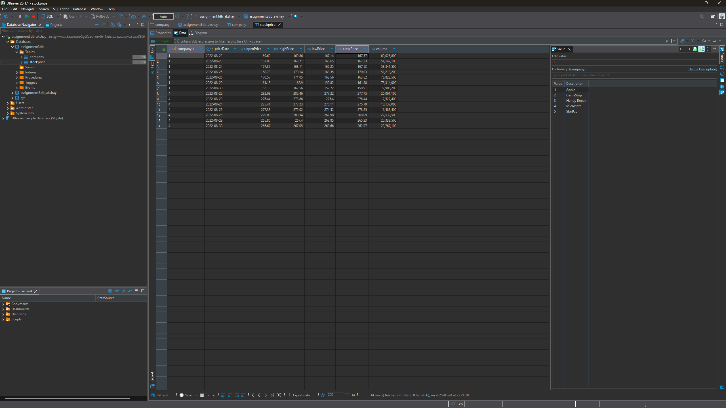

**Query 1 :**

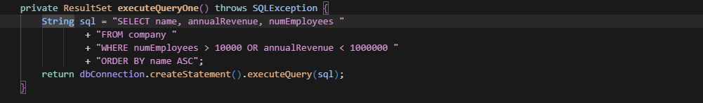

**Screenshot of Query 1 output :**

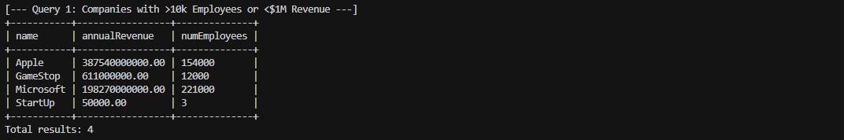

**Query 2 :**

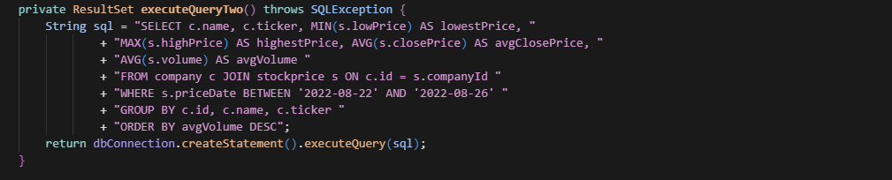

**Screenshot of Query 2 output :**

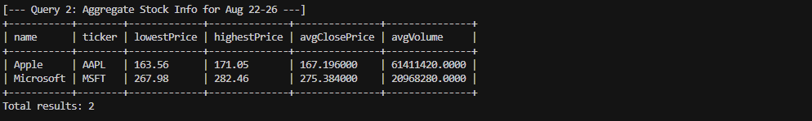

**Query 3 :**

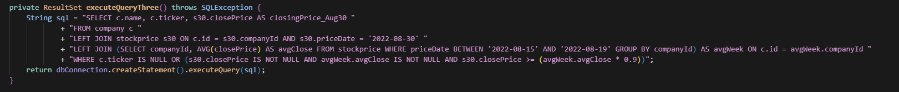

**Screenshot of Query 3 output :**

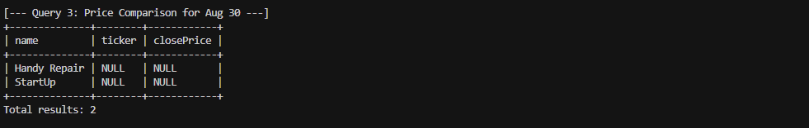

**resultSetToString(): I have replace resultSetToString() method with a new, custom-built display system.**

**I have also integrated the resultSetMetaDataToString() into displayResultSet() by using metaData.getColumnName(i + 1)**

